Guide for the Matlab Laser Scanning Microscope Software
ScanImage Version 1.0
Copyright 2001, Cold Spring Harbor Laboratory

Introduction

ScanImage controls a laser scanning microscope, such as a 2-photon or confocal. It is written entirely in Matlab 6.0 and makes use of standard National Instruments boards for data acquisition and output. The software generates the signals used to drive the scan mirrors and acquire and processes the signals from the photodetectors. Up to three channels (12-bits each) can be acquired simultaneously, and the software is written to be easily expandable to the maximum number of channels the NIDAQ board supports. Virtually no specialized hardware is required.

The ScanImage software also contains an image-processing environment and has the ability to acquire and run digital video acquisitions. These features can be added or removed without affecting the image acquisition software.

Table of Content

Section Description Page

Section 1 Software and hardware requirements for ScanImage.
Section 2 Step-by-step instructions on how to set-up ScanImage.
Section 3 The general logic of ScanImage from a user perspective.
Section 4 The ScanImage Graphical User Interfaces (GUIs) .
Section 5 The various acquisition modes and how to use them effectively.
Section 6 The signal conditioning requirements for ScanImage.
Section 7 The general logic of ScanImage from a programmer’s perspective.
Appendix A The file structure for ScanImage.
Appendix B Some useful Matlab editing and help commands.
Appendix C The image analysis environment.
Appendix D The integrated video acquisition system for the Matrox board.

1. Software and Hardware Requirements

- Since ScanImage requires heavy computation from the CPU, a computer equipped with a Pentium III (800MHz) Processor or better, running Windows 2000, is needed.

- Data acquisition and output is achieved using a 6110E board from National Instruments.
  - The BNC-2090 Breakout Box is preferred for attaching the actual BNC cables to the board and the scan mirrors/PMTs.

- ScanImage implements XYZ motion control via the serial port (COM2 by default) using the Sutter MP-285 stepper motor controller; the controller needs to be fitted with a custom controller named KS3.4 (available from Sutter).

- Matlab (v6.0 or better)
  - Need the supplemental data acquisition and image processing toolboxes (v 2.0 or better).

- National Instruments NIDAQ software (v6.7)
  - Matlab communicates to the boards via their NI drivers, included with this software.

- Stanford Instruments SR570 Amplifiers.

2. Setting Up the Program

Install the Data Acquisition Boards and NIDAQ Software
Install the NI 6110E data acquisition board (5 MHz input) and the NIDAQ v6.7 or later driver software and look at the “Measurements and Automation” (MAX) program to see the location of the board you just installed. Once you open the program, click the “+” sign next to “Devices and Interfaces” to list all installed NI boards. Note the index of the board you will use to acquire data and output the scanning mirror waveforms. This board index is what Matlab will use to configure the NI board.
If you are installing 2 boards, make a note of the indices of each board to be used. The second board can be a PCI-MIO-16-E and is used with ScanImage for interaction with scanning hardware, Pockels cell controls, and other additional controls. The name of each board is also listed when you click on the “+” from the MAX interface. If the boards have the same name, please note and label the boards as such to avoid confusion in wiring and configuration.

Install Matlab 6.0 or later
Matlab (6.0 or later) should then be installed with the appropriate toolboxes (Image Processing and Data Acquisition Toolboxes are required). On Windows 2000, an administrator needs to install and start Matlab before other users run it. If the administrator installs but does not start Matlab, other users get the following error message about writing to the registry when they start Matlab (they can run Matlab but must first dismiss the error message).
Unable to set Registry value
CLSID\{B3044B60-97FF-11D1-8146-00600815A7AD}\LocalServer32.
You may not have sufficient privileges. Rerun MATLAB as a user
with Admin access.
In addition, the administrator needs to run the command daqhwinfo('nidaq') in order for subsequent users to be able to do so (see below for usage details). Installation of all software should be done from an administrator login on Windows 2000 systems.
Note if you are installing Matlab 6.0 on a Pentium IV system:

If attempting to launch MATLAB 6.0 (R12) on a computer with a Pentium 4 processor one of the following errors may occur:

Failure Loading Desktop Class
Memory fault errors
Page fault errors
Any Dr. Watson error

This error occurs because there is a conflict between the Windows JRE (Java Runtime Environment) and the Pentium 4 processor.
A possible workaround is to replace the current version of the JRE with a newer version of the JRE (1.1.8_006). Though this has not been officially verified yet, preliminary testing has shown this to work. One location where this file can be found is:

http://java.sun.com/products/archive/jdk/1.1.8_006/jre/index.html
You can use the following steps to fix the problem:
- Download the Java Runtime Environment (1.1.8_006) from the above site (either the US English Version or the Internationalized version).
- Run the jre 1.1.8_006-win-i.exe to install the JRE. (The default destination directory is C:\Program Files\JavaSoft\JRE\1.1.)
- Rename the directory to C:\Program Files\JavaSoft\JRE\jre .
- Rename the existing $MATLAB\sys\java\jre\win32\jre directory to something, such as $MATLAB\sys\java\jre\win32\jre.old.
- Copy the directory C:\Program Files\JavaSoft\JRE\jre to the $MATLAB\sys\java\jre\win32\ directory. (You should now have at least two folders in $MATLAB\sys\java\jre\win32\: jre.old and jre.).

This should have completed your upgrade to JRE 1.1.8_006. You should now be able to successfully launch MATLAB.

Once Matlab is installed, you should check that Matlab recognizes the NI boards you installed. Matlab should automatically find installed data acquisition (DAQ) devices on the computer; type daqhwinfo('nidaq') from the Matlab command line to check if Matlab has detected the installed data acquisition board(s). If done successfully, they will appear in the ‘BoardNames’ field. If they do not, try restarting the computer and checking again. This needs to be done on Windows 2000 machines while logged in as the administrator.

The file structure for ScanImage is contained in a directory called ScanImage which needs to be placed in a Matlab path. It is recommended that it be paced in the Matlab work directory, although this is not necessary. Once placed where you want, setting the path is achieved by going to the File menu in the Matlab command window and selecting the submenu Set Path. Press the Add with Subfolders button and highlight ScanImage and to add all the files within ScanImage to the Matlab path.

Next open the initialization file and configure it for the computer you are using by typing edit standard.ini from the command line. This brings up an editable window with the text for standard.ini displayed. A few of the fields need to be checked before launching ScanImage to insure proper function. For convenience, all the fields that need to be updated are located at the top of the file. Finding the fields is easily done by pressing Ctrl+F and typing the fieldname into the find box, although reading through the file will be helpful later.

The following is an excerpt of the text from the standard.ini file with the fields that need to be set and their definitions.

%%%%%%%%%%%%%%%%%%%%%%%%%%%%%%%%%%%%%%%%%%%%%%%%%%%%%%%%%
%% The following variables are the ones that typically need to be changed for a new %% installation.

structure init
maximumNumberOfInputChannels=3
pockelsOn=0
autoReadZoom=1 Config 4 % flag determines if gain from rotation box
% is read with each acquisition

autoReadPMTOffsets=1 Config 4 % flag determines if automatic reading
% of pmt offsets occurs with
% each acquisition or focus. If off,
% offsets are only read in when a new
% config is selected or when the user
% chooses 'Get PMT Offsets' from the
% 'Settings' Menu
acquisitionBoardIndex=1
mirrorOutputBoardIndex=1
pockellBoardIndex=2
triggerBoardIndex=1
zoomBoardIndex=2
endstructure

structure video
videoOn=1 % Is video being used
endstructure

structure motor
motorOn=1 % flag to determine whether MP-285 is being
% used 1 = yes, 0=no

port='COM2' % serial port for MP-285 communication
baud=19200 % baud rate
endstructure

%%%%%%%%%%%%%%%%%%%%%%%%%%%%%%%%%%%%%%%%%%%%%%%%%%%%%%%%%

maximumNumberOfInputChannels

This should be set to the number of inputs you will use. Typically 3 are used: one for Green, one for Red, and one for trans-DIC images.

pockelsOn

This is set to 0 if you are not using a Pockels Cell, and to 1 if you are. If set to 1, a second board must be installed and configured (see below).

autoReadZoom

This is set to 1 if you are using a electronic rotation box and wish to record the zoom, and to 0 if not. If set to 1, a second board must be installed.

autoReadPMTOffsets

This is set to 1 if wish to read the dark (shutter closed) PMT settings befor eacquisition, and to 0 if not.

acquisitionBoardIndex
mirrorOutputBoardIndex
pockellBoardIndex
triggerBoardIndex
zoomBoardIndex

These need to be set to the board indices you recorded from the MAX software. The acquisitionBoardIndex, mirrorOutputBoardIndex, and triggerBoardIndex should be the same index (5 MHz board like 6110E), and the others should be set to the slow board index (like the PCI-MIO-16-E board).

The remaining fileds control the use of Digital Video (videoOn) and/or the Sutter MP-285 Stepper Motor (motorOn, port, and baud). Set these as follows:

- If you are using digital video, set videoOn=1. If not, set videoOn=0.

- If you are using the MP-285, set motorOn=1. If not, set motorOn=0.
  - Determine which Serial port the MP-285 is connected and set port=‘COMX’, where X is the port number.
  - Set baud=19200.
  - Set the Baud Rate on the MP-285 Controller to 19200.
    - This is done by:
      - Selecting PRGM on the front of the MP-285.
      - Hitting 0 2 times to highlite Setup and pressing ENTR.
      - Hitting 0 3 times to select Utilities and pressing ENTR.
      - Pressing ENTR to select Baud.
      - Pressing 0 4 times to select 192000 and pressing ENTR.
      - Pressing ESC 4 times to exit the configuration.
    - This must be done, since ScanImage requires this baud rate for efficient communication.\

N.B. ScanImage is intended to be used with a MP-285 motorized stage, and setting this field to off will limit the abilities of ScanImage.

If you are using a motor and/or video, be sure the devices are turned on prior to satrting the software.
The MP-285 needs to be turned on but the green “Move” button should not be pressed until after the software is loaded (The display on the MP-285 reads ***MP-285 Controller *** in this state). The software will update the MP-285 screen with coordinates if communication is established correctly, but manual control will not work until the green ‘Move’ button is pressed on the front of the MP-285. This should be done after ScanImage is started.

We have included a few functions in the ScanImage directory that are used for starting the program. Depending on you preference, a graphical interface can appear that allows you to select which application to run within Matlab, or you may open the software form the command line.

If you wish to use the Opening GUI interface, follow the following steps (this is recommended if Matlab was installed primarily to run ScanImage):

1) There is a top-level function called startup.m that will be executed whenever Matlab is opened. It can be used to set general Matlab preferences or to open other applications.

- Open the startup file by typing edit startup on the command line.

- Add the following lines of code to this file and Save the changes.

global gh
gh.openingGUI = guihandles(openingGUI);

- Close and restart Matlab.

When Matlab reboots, a GUI should appear allowing you to select the application to run. Click on the ScanImage 1.0 software to start the program.

If you do not wish to have the Opening GUI, then the ScanImage software may be started by simply typing ScanImage at the command line to start the program.

Regardless of the method used to start ScanImage, the software will open a window asking for you to ‘Choose User File’, which is a file with extension .usr. This file contains information about the layout of ScanImage and is discussed in great detail in Sections 3 and 6. If you do not select one (since you have not made one yet), it uses default setting. Hitting ‘Cancel’ will start the ScanImage set-up routine. The progress is reported graphically.

Start-up proceeds as follows:

- User selection of .usr file (lines 1-28).
- GUI setup (lines 29-39).
- Reading the .ini file and initializing the GUIs (lines 43-46).
- Configuring the Sutter MP-285 (lines 47-49 if being used).
- Setting up the Data Acquisition and Scanning devices (lines 52-60).
- Setting Up the Video software (lines 61-64 if being used).
- Reading User Settings (lines 66-72).
- Initializing the MP-285 (lines 74-77).
- Finishing-up and setting clocks (lines 78-91).

To see the start code, you can type edit ScanImage at the command line.

Once Main Controls say “Ready to Use” and the progress bar disappears the software is loaded correctly.

The final things to configure are the actual input and output channels the software will be using. For the input side, on the BNC-2090 Breakout Box, there are 16 input channels, labeled ACH0-15. Attach the red filtered PMT BNC cable to the ACH0 (Green Channel), the green filtered PMT BNC cable to the ACH1 (Red Channel), and the DIC BNC cable to the ACH2. These channels correspond in the software to Channels 1,2, and 3 respectively, as the board and software have a one-channel offset. There are only 2 output channels on the BNC-2090 Breakout Box labeled DAC0OUT and DAC1OUT, and these are attached to the mirror driving motors. By default, the DAC0OUT is for the fast scanning (X) mirror, while the DAC1OUT is for the slow scanning (Y) mirror, although this can be changed in the software (see the Basic Configuration GUI in Section 4 for details).

The system uses an internal digital (TTL) trigger for timed output and acquisition. This comes from the digital inputs/outputs on the BNC-2090 Breakout Box that are located on the right hand side. The connections should be made as follows:

- Connect the DIO0 output (TTL output) to the PFI0/TRIG1 BNC using the appropriate adaptors.
  - This is the trigger for the output of the scan mirror data.
- Connect the DIO0 output to the PFI6 wire hole on the digital input/output section of the board.
  - This is the trigger for the input from the PMTs.
- Connect DGRN1 to the ground.

N.B. The TTL digital hardware trigger is a falling-edge trigger, meaning that a high-to-low transition is necessary to fire the trigger and begin acquisition and output.

The shutters are also controlled with the acquisition board through the digital outputs via a TTL pulse. DIO1 is the default channel to use for the epi-fluorescence shutter and DIO2 is the default for the for the laser scanninfg shutter, although these can be set in the standard.ini file (see below).

The shutter controllers are usually connected by converting the wire outputs from the BNC 2090 breakout box to BNC cables, and then connecting them to the proper shutter driver devices.

The gating of the shutters can be set manually by opening standard.ini (type edit standard.ini at the command line) and finding the shutter structure using Ctrl + F. You should see the following:

structure shutter
open=1
closed=0
shutterLineIndex=1
shutterLine
epiShutterOpen=1
epiShutterClosed=0
epiShutterLineIndex=2
epiShutterLine
endstructure

The open and closed (and epiShutterOpen and epiShutterClosed)fields set what is defined as open and closed digitally. If your controller is open with a high signal (i.e. 1), that is the default used here. If not, switch the ones and zeros to match your shutter controller logic.

3. General Logic of ScanImage

ScanImage was written to integrate image acquisition and scan design into an environment amenable to sophisticated data analysis, such as Matlab. ScanImage was written to allow the user a large amount of flexibility in designing imaging experiments. It includes unique features that make it ideal for the most demanding experiments.

Two things dictate the flow of the program: user input or interaction with the GUIs and the programs own timing of responses to those inputs. Every time the user updates a field in a GUI, whether it is inputting a value into a field, hitting a button, or checking a box, a callback function is executed. Many of these callbacks do not do anything the user can see, but rather compute various parameters the software needs to accomplish a successful acquisition. Fields that are editable follow the standard Windows convention of being colored white, while un-editable fields (buttons, boxes, etc…) are either grayed out or hidden. This latter task is done by the software automatically to maintain stability and control the flow of the program.

Some callbacks do cause noticeable changes in the program. This includes the aforementioned graying out of fields, hiding controls, and opening and closing GUI windows. One of the other features utilized by ScanImage to control the program flow is utilizing “Modal” GUI windows. When these windows are opened (the Channel and Configuration windows, for example), no other functions are accessible until the window is closed. In addition, the Status String in Main Controls (see Section 4 for details) will display error messages and the progress of the acquisition.

The program uses a number of text files (.ini, .usr, and .cfg) and Matlab .mat files (both described below) to set various acquisition, output, and analysis parameters. The GUIs receive input from the text files for initialization, configuration, and user defaults, and from the .mat files for cycle definitions. The main text file is the .ini file, and it sets what fields will be used in the creation of subsequent text files (like .usr and .cfg files). Which fields from the .,ini get put into the other text files is set by the Config flag in the .ini definition.

The display of the GUIs is controlled via the Settings menu in Main Controls. Selecting the GUI from Settings opens it, while using the Windows default close command (mouse click on X) suffices to close the GUI. The only exception is the Current Image Viewer, which is controlled via the Analysis menu in Main Settings.

Initialization File (.ini)

This contains the .ini files. These files define the entire state variable with which the program interacts. These files are computer specific and are not meant to be updated regularly. It contains information regarding the tools used on a particular microscope (i.e. video, motor, Pockel’s Cell, etc…) .

.ini files are text files and are parsed by functions contained in the file_io\initialization directory to enable communication between Matlab functions and the GUIs. The logic is like other schemes in Matlab: there are parameter-value pairs that are parsed by the software. For instance, if you look at the standard.ini file, you will see a tree like (tabbed-in) structure and after a variable definition (like numberOfFrames) there is an “=” and then a value. This is the initial value of that variable and hence its corresponding field in one or more GUIs. Following the variable definition and initial value are a series of other strings (e.g. GUI, Numeric, Callback, …). These are parameters that tell the software to tie the given variable to the value that follows the parameter definition. For example, the parameter GUI is followed by the handle to a particular field in a GUI. When parsed, it will automatically update the state variable whenever the field in the GUI is changed.

The Callback parameter is followed by a function in the Matlab path. Whenever the corresponding variable is updated in a GUI, the function defined here will be executed. This provides a way for users to interface with the software without interfering with its core functions.

Configuration File (.cfg)

The configuration file is a text file like the .ini file, and is actually a subset of that file. It contains fields particular to a given experimental configuration, like the image size, averaging, and the number of channels to acquire. Configurations can be loaded and saved from the File menu in the Main Controls. Configurations can also be loaded as part of a cycle by choosing Select from the Cycle Controls window.

User Files (.usr)

The user file is a text file like the .ini file, and is actually a subset of that file. It contains fields particular to a given user’s preferred program display, including the positions and sizes of the GUIs, acquisition windows, a favorite configuration, and also if they prefer to start-up in Standard or Cycle mode. The .usr file can be loaded and saved from the File menu in the Main Controls. These files are typically loaded upon starting the program.

Cycle File (.cyc)

A cycle is a series of positions that coordinate defined acquisitions with pre-determined positions. The entire process can be timed and repeated to tailor the experiment to the needed situation. The cycle file is a Matlab (.mat) file that contains arrays of values for the parameters that need to be updated and changed when a cycle is executed. The .cyc file contains ordered arrays of parameter values for a particular cycle, while the physical positions to perform each step in the cycle can be loaded from a .pos file or input directly using the Cycle Controls window.

When the Cycle Controls window is opened, a cycle may be defined, saved, or a new one loaded by going to the File menu in Main Controls.

Cycles are gone over in depth in Section 5.

Position Files (.pos)

From the Motor Controls, you can define a list of positions and save those positions in a .mat file. This is used in conjunction with a cycle for design of complicated acquisitions. The current position is written in the file header when the image is saved to disk.

The data is acquired and stored in memory until the next acquisition is begun. You can view the data stored in memory using the Image Viewer described below, which provides a graphical representation of the data in memory. The data is logged to disk anytime the stage is moved and/or after all the data is acquired, depending on if a stack of images is taken or not.

Data Storage

The acquired image data is stored as 16-bit TIF images. The save path is selected by the user before acquisition, and the saving is done automatically, using the user defined Basename and the automatically updating acquisition # (See Main Controls for details).

The relevant information about an acquisition is stored with the data in the form of an image header. The header is a string that contains all the relevant acquisition parameters in a parameter -value format, using carriage returns as delimiters. The functions that read the header (or parts of it) from TIF files are included in the software.

Since stacks of images may be acquired on up to three channels simultaneously, ScanImage implements an interleaving protocol to save the images from different channels in the same TIF file. The program starts from the first frame on the first channel acquired and loops through the subsequent channels before moving to the second image. It repeats this way until all the data is loaded from memory to disk.

For example, say you acquired a stack of 10 images with 2 frames acquired per stack on 3 channels (60 images total). All 60 of these images are stored in the same TIF file. The order would be the first image of the first channel of the first slice, followed by the first image of the second channel of the first slice, and lastly the first image of the third channel of the first slice. The process is repeated for the second image in the slice, and then for subsequent slices.

If averaging is on, all the frames in a given slice are averaged into one image, and only this image is logged to disk. In the previous example, if averaging would have been selected, there would be a total of 30 images acquired, one frame in each slice for 10 slices on 3 channels.

If max is selected, the max projection is stored for each channel being acquired. By definition, there is only one image per channel for max projections, and the data is interleaved as described above. Max projections are only valid if you acquire 1 frame per slice or if you Kalman average over all the frames in a slice, so if Max is selected but these criteria are not met there will be no projection created or displayed.

4. Graphical User Interfaces (GUIs)

Opening Interface (Optional)

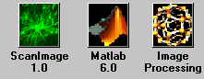

Optional GUI if the lines:

global gh
gh.openingGUI = guihandles(openingGUI);

are included in startup.m. It enables the user to select ScanImage, image processing, or return to the Matlab shell. Clicking the appropriate button does each.

Main Controls

Cycle Mode Display

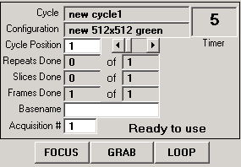

Standard Mode Display

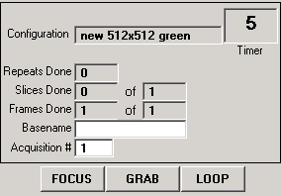

This is the central user interface and contains a menu bar that opens the other windows.
The first view is when the software is in Cycle mode, and the second is when it is in Standard mode.

Fields:
Cycle (cycle mode only) – Name of the cycle currently loaded.

Cycle Position (cycle mode only) – The current position of the cycle displayed in the cycle field. This is the cycle position actually dictating the scan parameters when an acquisition begins. The cycle will also start at this position if LOOP is pressed.
.
Configuration – Name of the configuration currently loaded. It changes when the cycle position increments (or decrements) if necessary.

Timer – Keeps a count of the time from the start of acquisition until the next acquisition begins. It is used primarily in cycles where timing is paramount.

Status – String that tells the user what the software is doing and any errors that occurred. In the above diagram, it says “Ready To Use” (Cycle mode)

Repeats Done – The number of times the current acquisition has repeated.

Slices Done – The number of different focal planes imaged.

Frames Done – The number of frames acquired in the current acquisition or given focal plane.

Basename – The user defined name that files will be saved as.

Acquisition # – The counter that distinguishes one acquisition from another. Increments automatically for saving purposes, and is appended to the base name and path to complete the save path.

FOCUS

The FOCUS button puts the software into a mode suitable for moving the stage and the focus of the scope to locate a structure to image. This mode does not save any data, but rather updates the image in real time in the acquisition windows. If you select image in the Channel window, you will automatically be able to focus on that channel as well.

GRAB

The GRAB button does a full acquisition determined by the settings the user desires. For instance, if there is only one Z-Slice and 10 frames, the data will be collected for 10 frames in that image plane. If the average button is checked, these 10 images from that plane will be Kalman averaged and only the averaged image will be saved. Similarly, if 10 Z-Slices are selected, 10 frames will be averaged in each plane and the stack will be saved.

The Grab button does one acquisition only.

LOOP

The LOOP button controls a series of acquisitions determined either by the current cycle or by the number of repeats selected in the standard acquisition GUI. It essentially loops indefinitely through the cycle acquiring data and saving it to disk. It is aborted by selecting ABORT from the main controls window, which is what the LOOP button says when pressed one time.

Movement

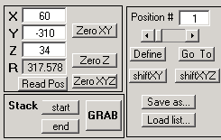

Controls the MP-285 motor directly and also defines pre-determined positions for the cycle. The motor is not in constant communication with the software. You may manipulate the MP-285 by the manual controls and it will not update the software until you read the new position into the GUI. However, you may move the motor via the GUI in real time.

Fields:

X,Y, or Z – Current X, Y, or Z relative position. Typing the position here automatically moves the motor to that new position.

R – Current distance from origin (square root of the sum of the squares of X,Y, and Z).

Read Pos – Read the current position of the MP-285 motor into the GUI.

Zero XY – Sets current coordinates of the motor to zero for relative position XY coordinates.

Zero Z - Sets current coordinates of the motor to zero for the Z (focus) position. This is useful when focusing.

Zero XYZ – Sets the current coordinates of all three directions to zero.

Stack Start – Define the current position as the start of a stack acquisition.

Stack End – Define the current position as the end of a stack acquisition.

Position # - The current counter for the positions function. You can define any number (up to 100) of XYZ coordinates as positions, labeling them with the number indicated here. Read below for the details of how to use this feature.

Define – Sets the coordinates of the current point to the position number indicated in the Position # field. These can be overwritten at will.

Go To – Will read the coordinates from the current position to the motor and update the GUI.

Shift XY – Will shift all the coordinates stored in the position array by the amount specified in the X and Y fields, leaving the focus (Z) alone).

Shift XYZ – Will shift all the coordinates stored in the position array by the amount specified in the X,Y, and Z fields.

Save as… - Save current list of positions as a .mat file.

Load list… - Load a previous positions list into the computer.

Standard

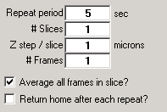

Contains the most commonly changed acquisition parameters and the repeat length to do the same experiment repeatedly.

Fields:

Repeat Period – The time in seconds between acquisitions.

# Slices– The number of different focal planes to image.

Z Step / Slice – The amount to increment (in microns) between Z-slices. This can be either positive or negative.

# Frames– The number of frames to be acquired in the current acquisition or given focal plane.

Average all frames in Slice? – If checked, the program will Kalman average over the number of frames per slice defined above. This is done for each Z plane.

Return home after each repeat? – Check this if you want to return the position of the stage to the home position in between acquisitions.

Cycle

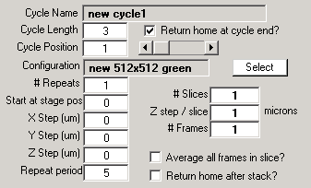

Interface that allows the user to predefine a cycle: cycles are timed series of acquisitions where the user specifies the type, length and position of each acquisition. There is no limit to the complexity or length of a cycle.

Fields:

Cycle Name – The name of the currently loaded cycle.

Cycle length – The number of positions defined in the current cycle. This needs to be set to some number greater than 1 in order to define a new cycle if one is not already loaded.

Cycle position – current position in the cycle

Configuration – The configuration the current cycle position will use for an acquisition.

Select – Define a new configuration as the one for the current cycle position.

# Repeats – The number of times to loop through the current cycle position before moving to the next position.

Start at Stage pos – Which position from the positions list loaded for the current cycle to start the acquisition.

X, Y, Z step – Move this many microns in the given direction between repeats of the current configuration.

Repeat Period – Time to wait before repeating a given configuration. This is the same as in the Standard window.

# Slices– The number of different focal planes to image.

Z Step / Slice – The amount to increment (in microns) between Z-slices. This can be either positive or negative.

# Frames– The number of frames to be acquired in the current acquisition or given focal plane.

Average all frames in Slice? – If checked, the program will Kalman average over the number of frames per slice defined above. This is done for each Z plane.

Return home after each repeat? – Do you want to return the position of the stage to the home position in between acquisitions.

Channel

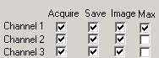

This allows the user to select which channels to acquire, save, image, and do running max projections . The check boxes for acquire, image and save automatically become checked when the acquire button is checked. The max box, however, does not update when acquire is checked.

Fields:

All the fields here set parameters for the various hardware channels. If you are doing a normal acquisition, simply check the acquire box next to the appropriate channel.

Acquire – If checked, the system will read in data from this channel.

Save – If checked, the acquired data will be logged to disk after each acquisition using the user defined save path and Base name.

Image – If checked, the program will display the acquired data. Image will do nothing if there is no acquisition (acquire not selected).

Max – This will compute and display a running max projection of the current channel. This may be selected without Image being selected. However, max is only meaningful if Kalman averaging is on or if the number of frames per slice is one, and it will only be computed if these criteria are met.

Basic Configuration

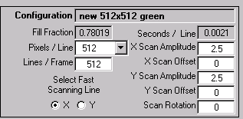

Contains basic scan parameters that can be user defined. It also sets which mirror is fast (line) and slow (frame) scanning. The other parameters are accessed through the menu bar by selecting the Advanced pull-down item.

Fields:

Configuration – Name of the current configuration with the displayed acquisition parameters.

Fill Fraction – Defines the fraction of time from the msPerLine that is used for image formation.

Pixels/Line – Select the resolution in the X direction.

Lines / Frame – Sets how many lines to acquire in a given acquisition.

Select Fast Scanning Line – Designates which direction for the fast (high frequency) scanning. The other is automatically set to the slow channel. By selecting one channel and setting the Scan Amplitude (see below) of the other to 0 puts the system in a line scan mode.

Seconds/Line – Displays the actual time that it takes to scan across the sample with the fast channel.

X/Y Scan Amplitude – Amplitude (in Volts) of the mirror oscillations. Larger amplitudes scan more of the sample per pass.

X/Y Scan Offset – Sets the zero of the scan oscillations. Effectively moves the laser around in the field of view.

Scan Rotation – Amount (in degrees) by which you would like to rotate the scan.

Advanced Configuration

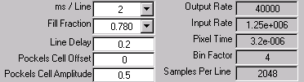

Contains more advanced acquisition parameters, such as Fill Fraction and Line Delay.

Fields:

ms/Line – Sets the time to scan across the sample in milliseconds. The software will actually set this to a different value depending on other acquisition parameters (like the Fill Fraction). The true value is displayed in the Basic Configuration field Seconds/Line.

Line Delay – The time in seconds to delay using data after the start of a line scan.

Pockels Cell Offset – Offset amplitude of Pockels cell output.

Pockels Cell Amplitude – Amplitude of Pockels cell output in Volts.

Output Rate – The current DA rate for driving the scan mirrors.

Input Rate – Current rate at which we sample the pixel intensities.

Pixel Time – The calculated time elapsed per pixel in the final image.

Bin Factor – Online processing of data requires adding pixel intensities over this many values to accumulate one pixel.

Samples Per Line – The actual number of samples acquired per line. This is binned according to the Bin Factor to yield the desired Pixels / Line.

Look Up Table

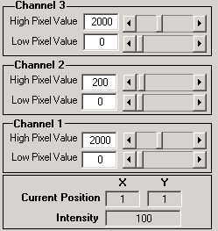

Allows control of the look up table for the imaging windows. Each channel has its own look up table controlled by this GUI. All the images on a given channel (acquisition, max, or in the current viewer) are controlled here. This GUI also has a display for the current position and the intensity of a pixel, which is updated simply by clicking on an image at the location you wish to get the intensity and coordinates.

Fields:

High Pixel Value – Any intensity equal to or above this value is displayed as white on the image.

Low Pixel Value – Any intensity equal to or lower than this value is displayed as black in the image window.

Intensity – The display for the intensity of the currently selected point. This is used when you click on a spot on an image.

Current Position X,Y – The current X,Y position of the selected pixel. Used the same as Intensity.

Image Viewer

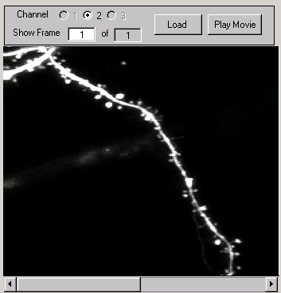

This allows the last acquired data set or one already stored on disk to be viewed or played back as a movie. The movie rate is hard coded (30 Hz) but can be changed. The Load button loads the data currently in memory into the viewer, using the Channel selector. The File menu is used to load an image from disk, and the menu Projections can be used to do maximal projections on the currently loaded image. Since this stores no data on disk, opening new images (including projections) overwrites ones previously loaded.

An image currently on the axes can be loaded into a new window by selecting Load Current Image to New Window from the File menu. This is very useful for exporting the current image (like a YZ maximum projection) as a .tif or .jpg file for use in a presentation, which is accomplished by selecting Export from the File menu in the new figure window. The loaded image can also be copied to the Windows clipboard by selecting Copy Figure from the Edit menu that appears in the new figure window.

Fields:

Channel – Determine which channel and data to make current. Refers to the current acquisition only, not to data opened from disk.

Show Frame – Which frame is being displayed currently. Loads new frame automatically when changed.

Load – Load currently selected data into window. This will only work for data in memory.

Play Movie – Display all the frames of a given channel as a movie.

Figure Windows

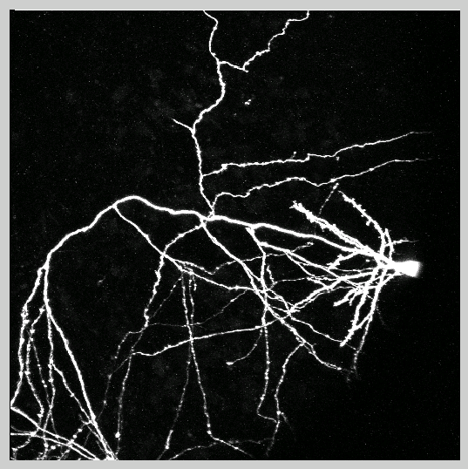

These are where the data is displayed. They are active in the sense that clicking on a position in a figure window updates the current position and intensity on the Look Up Table window (see above for details).

5. Designing an Experiment with ScanImage

Acquiring an Image I: Before Illumination

Before an image is acquired, a few things need to be done (especially if it the first time you are using the program).

First, open the various GUIs (from the Main Controls Window) and place them where you like. In particular, select if you are going to be using the more powerful Cycle Controls or the Standard controls (see the Main Controls menu Settings) more often. Also, change the number of channels and whether or not to do a running max projection, and see where you would like to place those windows. When every thing is setup the way you like, save the setup by selecting Save User Settings As…from the File menu in Main Controls. This will save the layout of the desktop for future use.

Now open the configuration settings by selecting them from the Settings menu in Main Controls and make sure they are correct. If not, make any changes that are necessary by updating the GUI fields. If correct, you are ready to save the configuration. You do this by selecting Save Current Configuration As…from the File menu in Main Controls.

Once this is complete, you must type in a Basename in Main Controls and select a save path for the acquired data. Saving of data in this software is done automatically by selection of the base name, path, and then appending to it the acquisition number (displayed in the Main Controls). To choose the save path, select Set Save Path from the File menu in Main Controls.

If you are using a cycle, open Cycle Controls by going to the Settings menu in Main Controls and selecting Cycle Controls. This will close the Standard window and open the Cycle Controls window. Define a cycle of acquisitions and positions (directions for creating a cycle are given below), when complete, you may save the cycle by selecting Save Current Cycle As…from the File menu in Main Controls.

If you are not using a cycle, define the number of slices, the number of frames, whether or not to average, the repeat period, and the Z-step per slice in the Standard window.

You can acquire up to three channels simultaneously. You set the channels to acquire by selecting Channels from the Settings menu in Main Controls. By default, when the channels are changed, ScanImage computes the dark channel noise for the PMTs (photomultiplier tubes). This PMT offset is then subtracted from the acquired data automatically. The exception is for channel 3, which always has a PMT offset of 0, since this is the channel used for DIC imaging, where the offset is integral to the image acquisition.

If these steps are done correctly, you are ready to begin acquisition.

Acquiring an Image II: Data Collection

Once the configuration defaults and cycle are saved, you are ready to begin data acquisition. There are three buttons located on the Main Controls GUI labeled FOCUS, GRAB, and LOOP. These are detailed below.

FOCUS

The FOCUS button puts the software into a mode suitable for moving the stage and the focus of the scope to locate a structure to image. This mode does not save any data, but rather updates the image in real time in the acquisition windows. If you select image in the Channel window, you will automatically be able to focus on that channel as well.

GRAB

The GRAB button does a full acquisition determined by the settings the user desires. For instance, if there is only one Z-Slice and 10 frames, the data will be collected for 10 frames in that image plane. If the average button is checked, these 10 images from that plane will be Kalman averaged and only the averaged image will be saved. Similarly, if 10 Z-Slices are selected, 10 frames will be averaged in each plane and the stack will be saved.

The Grab button does one acquisition only.

LOOP

The LOOP button controls a series of acquisitions determined either by the current cycle or by the number of repeats selected in the Standard window. It essentially loops indefinitely through the cycle acquiring data and saving it to disk. It is aborted by selecting ABORT from the main controls window, which is what the LOOP button says after it is pressed once.

Depending on the acquisition mode you selected, GRAB or LOOP will start an acquisition.

Acquisition Modes

Standard Acquisition Mode

In standard mode, the program runs much like the confoc or flouview interface. The stage position, basic scanning parameters, averaging, and maximal projections can be selected for each channel and changed rapidly. Many experienced users will find this mode extremely familiar and straightforward.

This mode allows the timed repeat of experiments and also allows most of the motor functions to be accessed directly. If you wish to do a single acquisition, simply press GRAB. If you want to repeat the acquisition a number of times, update the Repeat Period in the Standard window and press LOOP.

Cycle Mode

This is the more complex mode where the user may predefine positions and configurations to run in series. The user focuses and finds a list of positions on the sample they would like to image, and then they define a cycle through those positions matching up with scan configurations defined for those positions.

Cycle controls can be changed and displayed without the actual acquisition parameters being changed. The acquisition parameters only get changed if the Cycle Position in the Main Controls window is changed, not when it is updated in the Cycle Controls window. This allows the user flexibility in defining cycles independently of changing acquisitions parameters on the current configuration. To display a cycle, select Display Cycle from the File menu in Main Controls.

Creating a Cycle

- Be sure that Cycle Controls is open by selecting it from the Settings menu in the Main Controls window.
- Change the field for Cycle Length to match the number of different positions your cycle will have.
  - You will notice that the Cycle Name is not able to be changes. It is updated when you choose Save Cycle As… from the File menu in Main Controls.
- Set the Cycle Position to one and input into Cycle Controls the parameters for position one of your cycle. The definitions of each field are given Section 4.
- When done with the first position in the cycle, set the Cycle Position to two and repeat Step 3.
- When you are done, choose Save Cycle As… from the File menu in Main Controls.
  - This will update the Configuration and Cycle Name in the Cycle Controls window.

6. Signal Conditioning

One of the key advantages of ScanImage over other laser scanning systems is that it doe not require elaborate signal conditioning electronics. In particular, other laser scanning systems require that photocurrents are integrated over the duration of a pixel time electronically. Instead ScanImage acquires fluorescence time data at a very rapid rate (1.25 MHz) and then passes the task of integration to the CPU of the computer. Using a modern PC real-time digital integration can easily be achieved even using a high-level programming environment such as Matlab. The only signal conditioning requirement is that the PMT currents are converted to voltages and low pass filtered around 300-500 kHz. This can be achieved using custom-made amplifiers assembled for cents (for example see Horowitz, P., and Hill, W. (1989). The Art of Electronics, 2nd edition (Cambridge, Cambridge University Press)) or using a commercial product (SR570, Stanford Research Systems). For best results set the gain of your amplifiers to get several pixel values (5-10) per photon; for example, for Hamamatsu R3896 PMTs running at 800V a gain of 10 μA/V would be appropriate.

The analog output sampling rate (for determining the mirror driving functions) is set to 40 kHz and can be fed directly to mirror drivers. The output and input rates are set in the .ini file and should not be changed from their default values (40kHz, 1.25MHz) for optimal performance.

The input sampling is over-sampled by the amount set in the Bin Factor field in the Advanced Configuration window. For example, if you want 512 Pixels Per Line, ScanImage acquires that number of pixels times the Bin Factor. This is called the Samples Acquired Per Line and can be seen in the Advanced Configuration window The correct Pixels Per Line is achieved by adding the acquired intensities over the number of samples equal to the Bin Factor, and setting this sum equal to the intensity of the pixel in the image.

Even more samples than this are acquired, since we do not use some portion of the acquired data because the mirrors are not yet positioned correctly for image acquisition. In each output cycle, the mirror scans across the sample and then has to “flyback” across the sample to prepare for the next line of acquisition. The amount of time it takes to flyback is set in ScanImage by 2 other acquisition parameters: the Fill Fraction and the Line Delay. Fill Fraction is a parameter you can set from the Advanced Configuration window, and it in turn sets the flyback time. The Fill Fraction is the fraction of time the mirrors are actually acquiring data from a given line scan. If the line scan takes 2 ms with a Fill Fraction of .8, 1.6 ms of data is used to create an image every line. The Line Delay is the time in seconds to wait before collecting data for the next line in order that the mirrors may adjust from their own inertia. The default value is .2 seconds. All of these quantities are related by the equation:

where msPerLine is the amount of time it takes to acquire a single line of data. This can be updated in the Advanced Configuration window.

The acquisition is timed to be simultaneous with the output to the scanning mirrors via a digital trigger. This TTL pulse is delivered from the NI 6110E board itself and the wiring schematic is given in Section 2.

The data acquired form the NI board is in ‘Native’ format and is saved into uint16 arrays after processing. The timing of the input is achieved by ensuring that the Input Rate, Fill Fraction, Samples Acquired Per Line, and the ms Per Line variable are related as follows:

where the left hand side is the number of samples that need to be acquired in order to have Samples Acquired Per Line available for binning into the final pixel intensities (as described above). This equation is fundamental to bring accurate acquisitions to fruition. For a fixed Input Rate and Samples Acquired Per Line (these are fixed in ScanImage), only certain pairs of values for the ms Per Line and Fill Fraction will satisfy the above relation. These have been hard coded into the program, and are listed below for reference:

Set ms Per Line | Actual ms Per Line | Fill Fraction | Samples Acquired Per Line
 | 1.15 | 0.71234782608696 | 1024
1 | 1.1 | 0.74472727272727 | 1024
1 | 1.05 | 0.78019047619048 | 1024
 | 1 | 0.81920000000000 | 1024
 | 2.3 | 0.71234782608696 | 2048
2 | 2.2 | 0.74472727272727 | 2048
2 | 2.1 | 0.78019047619048 | 2048
2 | 2 | 0.81920000000000 | 2048
2 | 1.9 | 0.86231578947368 | 2048
 | 1.8 | 0.91022222222222 | 2048
 | 4.6 | 0.71234782608696 | 4096
4 | 4.4 | 0.74472727272727 | 4096
4 | 4.2 | 0.78019047619048 | 4096
4 | 4 | 0.81920000000000 | 4096
4 | 3.8 | 0.86231578947368 | 4096
4 | 3.6 | 0.91022222222222 | 4096
 | 3.4 | 0.96376470588235 | 4096
 | 9.2 | 0.71234782608696 | 8192
8 | 8.8 | 0.74472727272727 | 8192
8 | 8.4 | 0.78019047619048 | 8192
8 | 8 | 0.81920000000000 | 8192
8 | 7.6 | 0.86231578947368 | 8192
8 | 7.2 | 0.91022222222222 | 8192
 | 6.8 | 0.96376470588235 | 8192

The Set ms Per Line is the value the user sets in the Advanced Acquisition window, and ScanImage automatically chooses the Actual ms Per Line based on the user selected Fill Fraction. Note that for a Fill Fraction of .8192, the Set and Actual ms Per Line are identical.

7. General Logic of ScanImage from a programming perspective

The program uses a number of text files described above to set various parameters for the system simultaneously. These files are also parsed and create a structure array called state and gh. Structure arrays are like the normal tree structures you use in windows to store data. For instance the path C:\matlabR12\work\file specifies the location of file as being in the folder work in the folder matlabR12 that is on the C drive. In structure terminology, this would be written as c.matlabR12.work, since structures use periods and not back slashes as delimiters. If you type state at the command line, you bring up the first level of state, which you can then move down the hierarchy in by selecting state.acq to bring up the acquisition parameters. Finally, if you enter state.acq.numberOfFrames, Matlab will return the numeric for the number of frames in the current acquisition. This is where the data is stored in the state structure.

The GUIs interact with the state structure in the following way: each field in a GUI that you change correspondingly changes the value of a state variable (the converse is not true, however), and program looks to the state structure to determine what it should do. For example, the checkbox in the Cycle or Standard window that says Average? sets a flag telling the software whether or not to Kalman average all the slices in a given focal plane. It actually sets the value of the state.acq.averaging variable to 1 (checked) or zero (unchecked). The software then uses the information stored in state to accomplish the given command.

This previously described interaction between a global structure array and the fields in Matlab GUIs is generic. It provides an amazingly simple way to create and utilize the awesome graphics and numerical tools Matlab has to offer. The general methodology for creating and maintaining a GUI in Matlab is sketched below.

Creating a Matlab Graphical User Interface

- Type guide from the command line to open the Matlab graphical user interface builder. A nice introduction to using GUIDE for designing GUIs can be found in the Matlab help directory by selecting Full Product Family Help from the Help menu. Type Creating Graphical User Interfaces into the Search field and select it from the list.

  - Build your GUI by adding buttons, text fields, menu options, etc….

  - Be sure to give all editable or updated fields a tag. This should be a descriptive name that will also be the name of a structure field.

    - You can assign tag or declare any other property of a GUI filed by using the Property Inspector button located on the GUIDE toolbar.

  - When you are done, save the GUI by selecting Save format The File menu.

    - Saving automatically saves the layout as a .FIG file and creates a .M file with the same name. The .M file is where the Callback functions for all the buttons you created are located.

      - Menu item callbacks are actually coded directly into GUIDE via the Menu Editor.

- Once the .M file is created, a text file listing the name of your structure should be created. This file will exactly resemble a .INI file. The names of the fields and some appropriate initial value should be selected. A structure begins and ends with the declarations structure and endstructure, respectively. For example:

structure example
structure secondfield
variableWithSameNameAsGUITag=1 Gui guih.GuiName.GUIField
variableWithSameNameAsGUITag2=2 Gui guih.GuiName.GUIField2
endstructure
endstructure

will create a structure called example with a subfield called secondfield and with 2 end fields called variableWithSameNameAsGUITag & variableWithSameNameAsGUITag2.

These are written as example.secondfield.variableWithSameNameAsGUITag and
example.secondfield.variableWithSameNameAsGUITag2. The values initially set for these variables are 1 and 2, respectively, as indicated in the text file.

  - Although not necessary, it is vastly easier if the fields of your GUI and the names of your variables in the structure are identical.

    - This implies that variableWithSameNameAsGUITag would have the same name as GUIField.

- The text next to the variable definition (e.g. Gui guih.GuiName.GUIField) describes what GUI and what field of that GUI are connected to that structure field.

  - Many GUI fields can be connected to one structure field, but the converse is not true.
    - To add many Gui fields to one structure variable, just repeat the text (including Gui) with the new name (e.g. Gui newName).

  - The actual GUI fields can be extracted from the GUI .M filename using the Matlab function guihandles. This function takes the filename of the GUI as an input, and it returns a structure containing the tags for all the fields in the GUI. This is why it is very important to fill in the GUI tag property when making the GUI.

    - Guihandles also opens the GUI figure.

  - Thus, you create another structure array containing the GUI tags, and these are what are input in the text file (see a above).

  - The start up script for your GUI will contain the following line which creates the GUI structure:

guih.GuiName = guihandles(GuiName)

- Once the text file is created, it should be saved with the extension .INI. The next line of the start-up for your GUI will be to initialize the GUI you created using the initGUIs function. This function will actually create the variable structure and tie the designated GUI fields to that structure.

initGUIs(name.ini);

- If successful, all of the GUI fields will be updated with the initial values and tied to the correct GUIs.
  - Other text fields can also be set in the .INI file and follow the Gui guih.GuiName.GUIField text. See list below:

    - Numeric 1
      - Ensures field is always a numeric vale.

    - Min/Max Value
      - Sets the min and max values for the field. Useful for sliders.

    - Callback FunctionName
      - Sets a function that is executed whenever the GUI is updated.
      - This is a very nice way to interact with ScanImage without changing the code.

- The .M file for the GUI can now be updated.

  - In order for the automatic updating described above to work, the genericCallback(h) function must be included in the callback.

  - Now, when you update a GUI field the structure value is also updated.

  - Add other functions to the callback as necessary.

  - You are now ready to create and use the GUI a needed function.

- Other Useful Hints:

  - When a GUI is updated so is its structure variable, but the converse is not true. Updating a structure variable will not update the GUI automatically.

    - This is accomplished by the function updateGUIByGlobal (‘StructureVariable.NameAs.String’);.

  - If you are using editable text boxes, set the min to 0 and the max to 1. Then use sliders to change the values with min and max set normally. If you do not do this, when the user enters a value into the text box and hits enter, the cursor will move to the next row of text, not enter the value and execute the callback.
  - If you receive an error that the sliders are out of range, go into GUIDE and set their Value to one that is in the min/max range.

Appendix A:

File Hierarchy and Descriptions

The following is a diagram of the tree structure used for the software:

Level 1 Level 2 Level 3

ScanImage

guis

flow_control

gui_building

gui_callbacks

gui_handling

init_files

io

ad_da

data_in

data_out

file_io

configurations

cycles

data

initialization

positions

users

motors

MP-285

documentation

utilities

image_processing

video

ORCA

milmex_Win32

ScanImage

Directory that contains the files needed for 2-photon laser scanning microscopy acquisition and output.

guis

Contains both the specific files that create the layouts of the windows and figures and the generic code that simplifies the interaction of the GUIs with Matlab functions. It also contains several “Callback” functions. Callbacks are functions that get executed when a field of a GUI is updated.

flow_control

Contains the files responsible for looping through configurations and the coordination of acquisitions.

gui_building

The actual .fig files that layout the GUIs and their associated .m files are here. The function makeImageFigures is included here, as it is responsible for creating the image windows.

gui_callbacks

Any function that is triggered by the update of a filed in a GUI is here. Also included are secondary callback functions. These are functions that update dependent parameters when one variable is updated and not another. Many of these secondary callbacks execute mathematical operations and determine the value of other variables. For example, when the user updates the msPerLine (milliseconds per line) variable, the pixel time is recalculated and updated also.

gui_handling

This directory has the files that parse the .ini, .usr, .cyc, & .cfg files and update the GUIs from that data.

init_files

This contains the .ini files. These files define the entire state variable with which the program interacts. These files are computer specific and are not meant to be updated regularly. It contains information regarding the tools used on a particular microscope (i.e. video, motor, Pockel’s Cell, etc…) .

.ini files are text files and are parsed by functions contained in the file_io\initialization directory to enable communication between Matlab functions and the GUIs. The logic is like other schemes in Matlab: there are parameter-value pairs that are parsed by the software. For instance, if you look at the standard.ini file, you will see a tree like (tabbed-in) structure and after a variable definition (like numberOfFrames) there is an “=” and then a value. This is the initial value of that variable and hence its corresponding filed in a one or more GUIs. Following the variable definition and initial value are a series of other strings (e.g. GUI, Numeric, Callback, …). These are parameters that tell the software to tie the given variable to the value that follows the parameter definition. For example, the parameter GUI is followed by the handle to a particular field in a GUI. When parsed, it will automatically update the state variable whenever the field in the GUI is changed.

The Callback parameter is followed by a function in the Matlab path. Whenever the corresponding variable is updated in a GUI, the function defined here will be executed. This provides a way for users to interface with the software without interfering with its core functions.

io

This directory contains the software that interacts with the NIDAQ board and is responsible for the data acquisition and the driving of the scan mirrors. It also contains the online processing tools, including binning, averaging, and maximal projection functions.
ad_da

Contains the files responsible for setting up the data acquisition objects. This includes making and updating the output to the scanning mirrors and the acquisition of pixel values from the PMTs. Also included are the commands for the shutter switch, the PMT offsets, and the focusing controls.

data_in

Files that manipulate the acquired data and format it into an image. These include the action functions that are paramount for real time data acquisition and display.

data_out

These file create and output the scanning mirror signals.

file_io

This directory contains the software for the opening, closing, and saving of various parameters and files in the software. The .ini, .cfg, .usr, and .cyc parsing, loading and saving functions are here, as are the functions that write the acquired data to disk. The functions that write the header into the image and parse that header are included, as are the functions controlling the positions the user defines during a cycle.

configurations

The file input and output functions for .cfg files. This includes loading .cfg text files into the workspace and creating .cfg text files based on the current workspace state.

cycles

The file input and output functions for .cyc files. This includes loading .cyc (.mat files) into the workspace and creating .cyc (.mat files) based on the current workspace state. Also included is the code for changing cycle positions in dynamic memory.

data

The input and output functions for the image header construction and parsing. The header is a string that contains all the relevant acquisition parameters in a parameter value format, using carriage returns as delimiters. The functions that read the header (or parts of it) from .tif files are included here.

initialization

The file input and output functions for .ini files. This incl
udes loading .ini text files into the workspace and creating .ini text files based on the current workspace state.

positions

The file input and output functions for position files. This includes loading position files into the workspace and creating position .mat files based on the current workspace state.

users

The file input and output functions for .usr files. This includes loading .usr text files into the workspace and creating .usr text files based on the current workspace state. The .usr file stores the positions of the GUIs and figures on the screen.

motor

The software makes use of a motorized stage in order to locate object for imaging and, more importantly, for focusing up and down on a specimen. These are the functions that configure and interact with the motor controlling these motions. The Sutter MP-285 is the primary one used, and many functions are written specifically for this device. These include functions that set, query, and zero the motor position.

MP-285

The software makes use of a motorized stage in order to locate object for imaging and, more importantly, for focusing up and down on a specimen. These are the functions that configure and interact with the motor controlling these motions. The Sutter MP-285 is the primary one used, and many functions are written specifically for this device. These include functions that set, query, and zero the motor position. These are included here.

documentation

This file contains known bugs (Matlab and software specific), directions, and more details on the setting of acquisition parameters.

utilities

General functions that would be useful in many applications in Matlab. This is not an exclusive set, as many of the functions used in the software are also general in their implementation.

Appendix B:

Useful Matlab Help and Editing Tools

help filename

Typing this at the command line brings up the help file associated with a given Matlab script. The help file is the commented section of a function that appears under the function declaration.

edit filename

Typing this at the command line opens the function source code up for viewing and editing.

which filename

Typing this at the command line returns the path in which the file is stored.

daqfind

Displays all of the currently loaded data acquisition devices.

get(objecthandle)

Displays the properties of the object with handle objecthandle.

Appendix C:

Image Processing Environment

ScanImage contains additional software for reading and manipulating acquired data, including batch processing, averaging, and parsing multiple channels simultaneously. It opens and manipulates the images in dynamic memory, so care must be taken when opening very large image files. If this is a problem, the software can be manipulated to only open a selected number of images from a stack very easily.

File Structure

image_processing

Contains the files needed for the image processing software, which is accessible either alone or from the ScanImage software. Just select Image Processing from the Analysis menu in Main Controls.

ExcelFIO

This directory contains functions that can open and manipulate Excel workbooks (.XLS) files from Matlab. This is very useful since Matlab does not have a built-in data manger like Excel.

Image_statistics

Contains functions that calculate statistics for images, like the photons per pixel value.

ImageDrawing

Contains functions that interact with intrinsic Matlab drawing functions for quantitative analysis. For instance, determining the bounds of a zoom or the position of a drawn line in a figure window.

KarelsCFDCode

Code that can extract the data and the header from a .CFD (Confoc) data file.

Spines

Functions that are used for spine analysis, including a number of binary image operations.

Graphical User Interfaces

Image Processing GUI

This is the main control window for the image-processing environment. The menu option File allows you to open new images as well as Load regions of interest (ROIs) from currently opened images. Supported formats are .CFD (confoc), .TIF, and .JPG. Only the former two can contain multiple images saved as stacks. The rest of the windows can be opened and closed from this window as well.

Numerous image processing features have been integrated here, including histograms (2D and 3D), contour plots, selecting colormaps, and 3D image reconstruction. Additional features such as de-blurring, convolution, and smoothing can also be added simply.

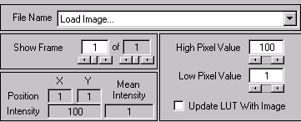

Fields:

File Name – Displays the name of the current image. The pop-up menu allows you to switch between all the images currently loaded in memory. All the parameters in all the windows update when this is changed.

Show Frame –These counters automatically load sequential frames of a multi-framed image. The maximum is set automatically to coincide with the size of the image. The second counter (after “of”) allows you to select the end frame for selecting ROIs (see below).

Position – Current X and Y position of selected Pixel. This is updated whenever an image is clicked on with the mouse pointer.

Intensity – Current intensity at the X and Y position of selected Pixel. This is updated whenever an image is clicked on with the mouse pointer.

Mean Intensity – Average intensity of all the pixels sin current frame. This updates every frame automatically.

High/Low Pixel Value – Sets the Look up table (intensity for white/black cutoffs) in the display. Each image has its own LUT.

Update LUT with Image – If checked, a new LUT is loaded for each image loaded. If unchecked, the same LUT table applies to all images loaded.

File Counter

This allows the automatic loading of files saved in sequence (basename + 0 + acquisition number), like those saved in ScanImage. The menu option File allows you to select an Open Path for the images saved on disk, and it tries to extract a base name from the file name selected. The Load Image button then loads that image automatically.

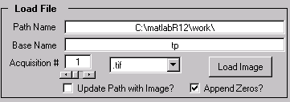

Fields:

Path Name – The path for opening the image. This can be set from the File menu.

Base Name – The base name for all images in the path selected. The software tries to select one , but it may need to be updated.

Acquisition # - The counter for paging through files.

Update Path with Image – If checked, a new path is loaded for each image loaded. If unchecked, the same path applies to all images.

Append Zeros – If checked, the basename needs to only contain the non incremented portion of the filename, and zeros are appended to the base name to insure that when the Acquisition number is double digits, the correct name is selected for loading. For instance, if the filename in the selected path is q303a001, the base name would be q303a0, since the software will automatically append the second zero to the file name until the acquisition counter reaches 10, when it no longer needs to append the zeros.

File Type Pop-up menu (.tif) – Select the extension of the file to be loaded.

Load Image – Load currently defined image into the image-processing environment.

Maximum Projection GUI

This allows a maximum projection of any image currently in memory to be loaded and saved. The counters dictate which frames to do the projection over and the direction to do the projection. Selecting the menu option Load Projection from the File menu computes and displays the projection, which then needs to be saved from the Image Processing window using the Save Current ROI command from the File menu.

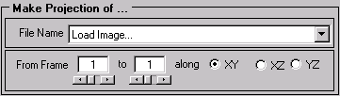

Fields:

File Name – This pop-up menu controls which image is currently displayed and used for the projection desired.

From Frame – Counters that dictate the boundaries for the projection. These are set to all the frames by default.

XY, XZ, YZ – Direction to do the projection along. The missing coordinate is the dimension that gets collapsed. For instance, an ‘XY’ projection collapses along the z-axis.

Image Parsing GUI

This displays the important information about an image file, including its header. The fields here are actually derived from the header. The supported formats for parsing are the ScanImage and Flouview .TIF formats, which both use the ImageDescription field of the generic .TIF header. By inputting the data or allowing the software to determine the acquisition parameters, multi-channel images can be extracted channel-by-channel and displayed and saved. This is done via the Parsing menu.

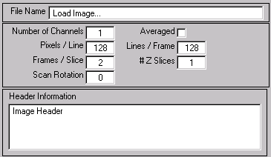

Fields:

File Name – This test box shows the name of the image currently displayed. It is not editable, so the current image must be loaded in order to parse it.

Number of Channels – The number of different channels present in the current image file. By default, the software assumes interleaved channels when parsing the image (ScanImage files are saved this way). If the different channels are stored as blocks (like in Flouview), the Image Processing window can parse these easily.

Pixels/Line – The resolution in the X direction.

Frames / Slice– The number of frames acquired in the current acquisition or given focal plane.

Scan Rotation – Amount (in degrees) the image was rotated for acquisition.

Averaged – If checked, the data has been Kalman averaged over the number of frames per slice. This is done for each Z plane.

Lines / Frame– The resolution in the Y direction.

# Slices– The number of different focal planes imaged.

Header Information – String containing the fields read from the image header. If no header is found, the display reads “No Image Description Found.”

Batch Processing

This GUI allows the user to select a series of files saved in an incremented format (see the File Counter above), read the data from them, do a manipulation of that data, and save the transformed file in a different directory.

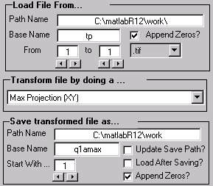

Fields:

Path Name (Load) – The path for opening the image. This can be set from the File menu.

Base Name (Load) – The base name for all images in the path selected. The software tries to select one, but it may need to be updated.

From … - The counter for opening files. It creates and increments the fields to be opened like in the File Counter window.

Transform file by doing a …– Pop-up menu to select what transformation you would like to do to each file opened.

Path Name (Save) – The path for saving the transformed image. This can be set from the File menu.

Base Name (Save) – The base name for saving the transformed images in the save path selected. The software tries to select one based on the load Base Name, but it may need to be updated.

Start With… - Counter for saving the transformed images. Counter starts with this number.

Update Save Path? – If checked, when an image is loaded the save path is updated.

Load After Saving? – If checked, the newly transformed image is loaded into the Image Processing environment.

Append Zeros? - If checked, the basename needs to only contain the non incremented portion of the filename, and zeros are appended to the base name to insure that when the Acquisition number is double digits, the correct name is selected for loading. For instance, if the filename in the selected path is q303a001, the base name would be q303a0, since the software will automatically append the second zero to the file name until the acquisition counter reaches 10, when it no longer needs to append the zeros.

File Type Pop-up menu (.tif) – Select the extension of the file to be loaded.

Overlay

This allows an RGB image to be constructed from overlaying images from opened files. Each image can also be weighted to allow for intensity correction between channels. The image can be saved as a .BMP file by selecting Save Overlay As… from the File menu. It can be loaded into the image analysis environment by selecting Load Overlay from the File menu.

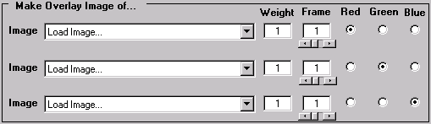

Fields:

Image – Allows the user to select which image the frame to be overlaid is found. This is done without loading those selections as the current image.

Weight – This is a multiplicative factor that allows the user to compensate for images with different intensities. The image loaded onto the overlay is the original times the weight factor.

Frame – Which frame of the selected image to load into the overlay.

Red, Green, & Blue – Which color to assign the selected image. No two images can have the same color assigned to them.

Excel Link

This provides and interface with an excel worksheet, since Matlab does not contain a spreadsheet interface. These functions (found in the Excel Link folder in the ImageProcessing directory) can be integrated into other applications for automatic reading and saving of data in an excel worksheet. An Excel file (.XLS) can be opened from this window by selecting Open Excel Workbook from the File menu. It will prompt you to connect to the field once it is opened. Selecting Yes will make the Excel sheet link to the Matlab workspace.

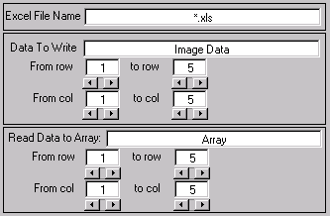

Fields:

Excel File Name – Name of the Excel file opened and connected to Matlab.

Data To Write – Enter an array to be sent to the opened Excel sheet.

From Row/Column – Specify where the data is read from and to on the Excel sheet.

Read Data to Array – This will extract Data from the Excel sheet and write it into a Matlab variable specified here. This variable should be global for command line access.

Averaging

Allows an image file to be averaged over any integral number of frames. Averaging here involves replacing a given pixel (or voxel) by the average of those pixels around it. The user specifies the area (volume) of these surrounding pixels through the fields Bin By:. The software determines the type of averaging from the inputs. For instance, if there is an intrinsic image stack of 10 images and the user wants to average over all 10 frames, keeping the X and Y resolution fixed, they would enter Bin By: 1 Along X 1 Along Y 10 Along Z.

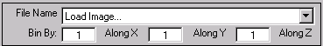

Fields:

File Name – Allows the user to select which image to do the averaging. This is done without loading those selections as the current image.

Bin By: … Along X,Y, & Z – The program will reduce the total image size by these dimensions. For instance, if a 512x512x10 image is selected for averaging by 2 Along X 4 Along Y and 5 Along Z the resulting image would have dimensions 256x128x2.

Montage

Display multiple frames of an image simultaneously (in the same figure). This is useful for seeing all of the data at once.

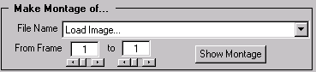

Fields:

File Name – Allows the user to select which image to do the montaging. This is done without loading those selections as the current image.

From Frame – Counters that dictate the boundaries for the montage. These are set to all the frames by default. However, for large stacks (more than 30) the display will be very small, so selecting pieces could be useful.

Show Montage – Displays a montage of the frames selected.

CFD Viewer

For reading Confoc .CDF files. Enter the number of channels for proper parsing.

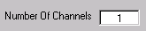

Fields:

Number Of Channels – .CFD parameter for parsing these images correctly.

Array

Takes the name of an array and loads it into the image analysis environment. The name can be a global array or a Matlab definition (like rand(128,128)).

Fields:

Load Array – Will load the specified array like an image selected from a file.

Generic Look Up Table

Graphical look up table interface. Works with any image not contained within a GUI. You can select an image by clicking on it and get its current LUT by selecting Get Current LUT from the File menu.

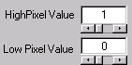

Fields:

High/Low Pixel Value – Sets the Look up table (intensity for white/black cutoffs) in the display. The image must have the property ‘CDataScaling’ set to ‘manual’ for this to work. This is done automatically in Matlab by the imagesc function.

Spine Analysis Program

This can be accessed by selecting Spine Analysis Program from the Image Processing menubar. This is a program designed to allow one to identify, label, count and calculate spine and dendrite properties. It sends data out to an excel worksheet, and the labeled images can be saved as .tif images and/or copied to the windows clipboard for pasting into the excel worksheet.

Many of the saving features are automated, as is the data interaction with Excel. 2 stacks of images may be loaded (multi-tif or cfd files) and manipulated in this shell. Their look up table can be changed, and maximal projections or median filtering can also be performed.. The large axis is for spine analysis, and its LUT is controlled by the same controls as the top image on the left. The lower right image is there so that an analyzed image with markings can be loaded for reference. Each axis has zoom functions and a copy (to clipboard) button associated with it.

The spine analysis can be done manually or automatically. In many cases the results are the same for the spine number and density, but many more properties of the spines can be analyzed if they are auto-detected, such as their areas, locations, and orientations.

Manual Spine Analysis

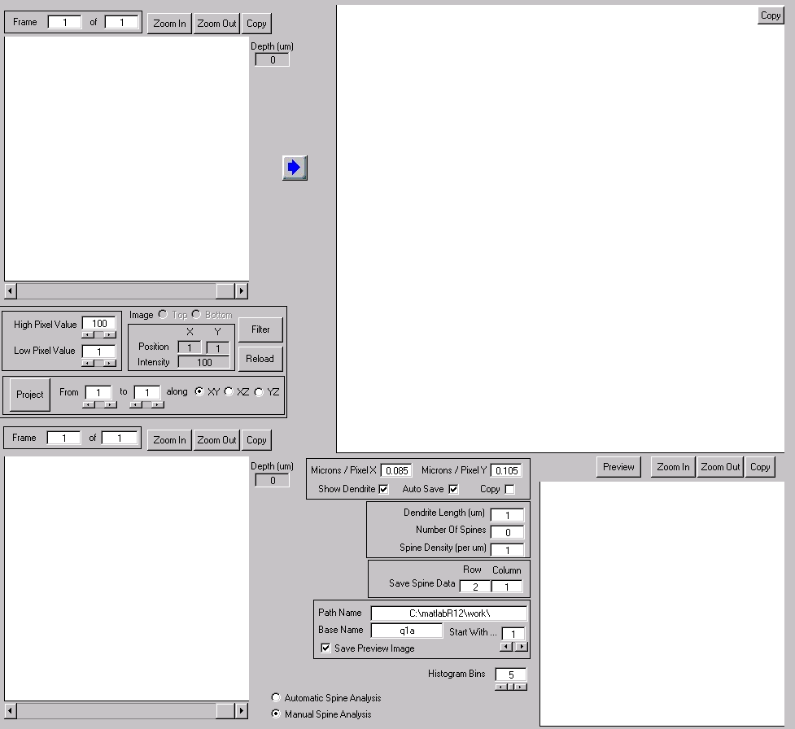

General Information

Manual analysis sessions are designed to be painless. A stack of images can be loaded by pressing either Ctrl+T or Ctrl+B to load the stack to the left top or bottom axis, respectively. You can also do this using the mouse by selecting from the File menu. Once loaded, the Top and Bottom radio buttons will designate which image the controls (like Filter and Project) manipulate. Only one may be manipulated at a time. The depth field located adjacent to the top and bottom axes indicates the focal depth of the current slice.

After appropriate processing and projecting, the image displayed either in the top or bottom windows may be loaded for analysis. This is done by pressing the right arrow key (either graphical or on the keyboard). The image is then sent to the main axis for analysis.

Spine Selection

The user begins a spine detection session by pressing Ctrl+A or selecting from the menubar. The cursor will turn into a crosshair, and left-clicking on the main axis will leave a cursor imprint where the click occurred. The user defines the primary spine by 2 cursor marks, one at the base of the spine and one at the end of the spine. If the spine is bent (or if it is a filopodia protrusion), subsequent cursor clicks (up to three more) can be made by using the Shift + Left-click command. When the entire spine is defined, simply click the beginning of the next one to move on. If you make a mistake, the delete key removes selected points, so you can edit your selections.

When you are done, hitting Enter or Right-clicking auto draws the spines and calculates their properties. The data is sent out to an excel workheet.

Dendrite Length

You should define a dendrite length if you wish to compute the spine density. This is done by pressing Ctrl+L or by selecting from the menubar. Simply click along the dendrite and hit enter when you are done. The dendrite is drawn in green and the dendrite length is updated on the screen.

If no dendriote length is defined, the spine density and dendrite length fields are lleft baln in the excel sheet.

Excel Interface

When you open the Spine Analysis program, a prompt will appear asking if you would like to open an excel workbook to output and store the data to analyzed. There is a default sheet in the ImageProcessing\Spine\ directory called ‘SpineData.xls” which has the format shown below.

Data is always sent out in this format, so these fields need to be present in your analysis or personal excel sheet.

The From: and To: fields indicate where in space (Z-only) the images were taken in the sample. These are defined from the image acquisition parameters. Analysis of max projections fills in these fields with where the max projection started and ended.

Saving

The software can save the main image along with the preview image if desired. This is

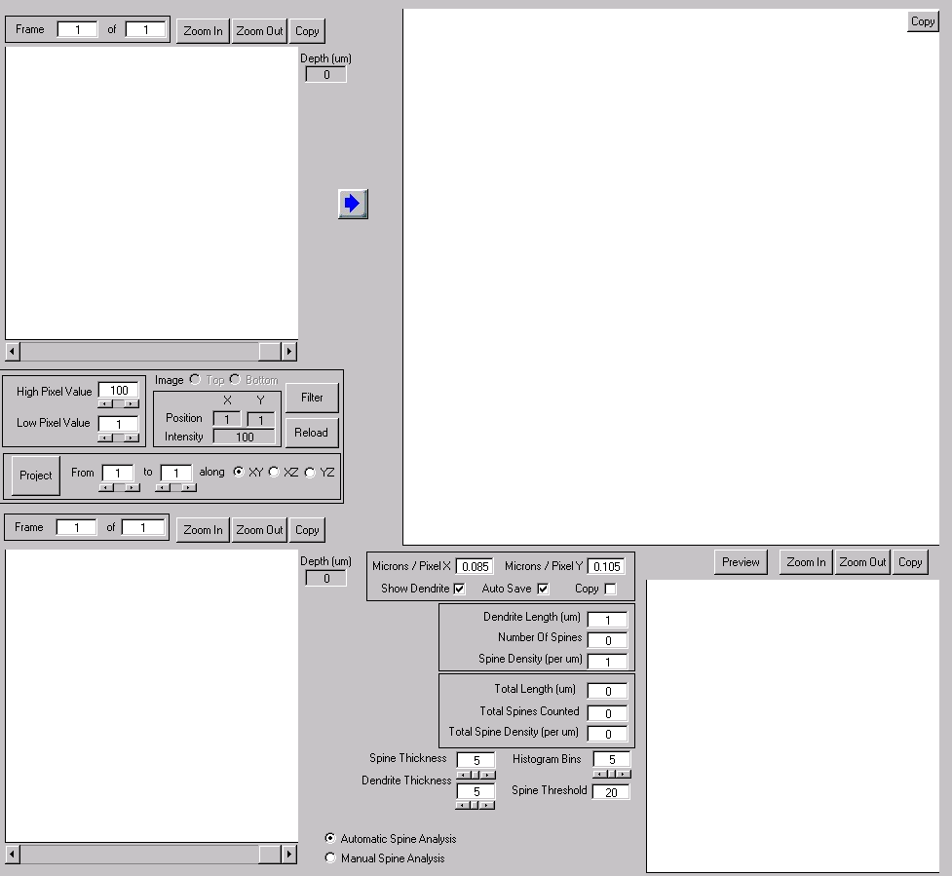

Appendix D:

Digital Video Microscopy

ScanImage can also be made to control a CCD camera/digital frame grabber driven video input.

File Structure

Video

Directory that contains the files necessary to acquire digital video images.

ORCA

Contains files that communicate with the CCD camera.

milmex_Win32

Contains the files that interact with the digital frame grabber.

Graphical User Interfaces

Video

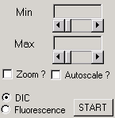

Controls the digital frame grabber and camera for acquiring images and video.

Fields:

Min/Max – Look Up Table for the video display.

Autoscale ? – Should the software auto-scale the images being grabbed.

Zoom ? – Should the software acquire zoomed images?

DIC – This is the radio button to select if DIC is being acquired.

Fluorescence – This is the radio button to select if epi-Fluorescence is being acquired.

Start – Start a video session. This will say “Stop” when pressed and if pressed again will stop the current video acquisition.

